**JDY-16 BLE**

**Bluetooth module instruction manual**

**V.1.1**

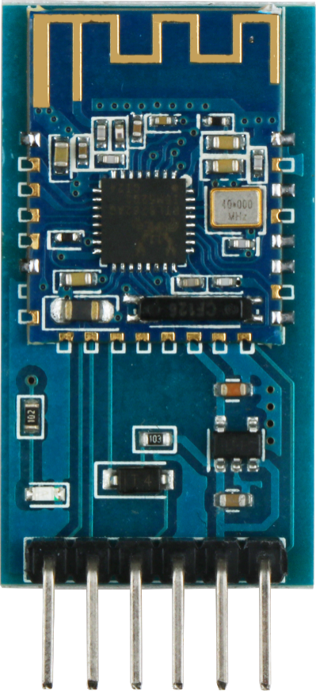

**Revision history**

|  |  |  |  |
| --- | --- | --- | --- |
| **Date** | **Version** | **Description** | **Author** |
| **2018-11-27** | **V.1.0** | **Create** | **Abbott_Chen** |
| **2019-07-22** | **V.1.1** | **Modify** | **Bella** |
|  |  |  |  |
|  |  |  |  |

contents

一 Overview 4

二、Testing the bluetooth **错误!未定义书签。**

2.1 the bluetooth module and Arduino connection **错误!未定义书签。**

3.2 burning the bluetooth testing program 5

3.3 connect the bluetooth 8

3.4 Mblock testing program **错误!未定义书签。**

3.5Mixly graphical programming program **错误!未定义书签。**

# 一 Overview

This manual introduces the use method of bluetooth module. Please refer to the manual hummer-bot-2.0 Chinese manual _v.2.1 for the program running and debugging of other parts.

# Testing the bluetooth

## 2.1 bluetooth module and Arduino connection

|  |  |
| --- | --- |
| Arduino UNO | JDY16 bluetooth module |
| VCC | +5V |
| GND | GND |
| 3 | TXD |
| 2 | RXD |

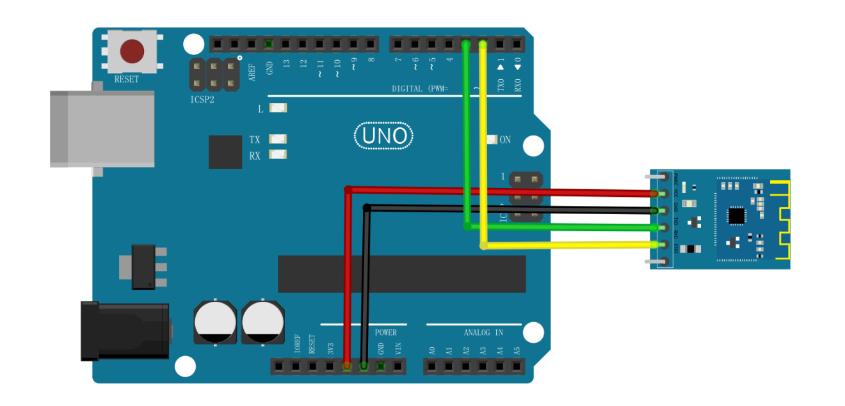

图2-1-1

## 3.2 burning the bluetooth testing program

1) connect Arduino UNO to the computer via USB;

2) click "file -- open -- select Ble test.ino -- open", as shown in figure 3.2.1.

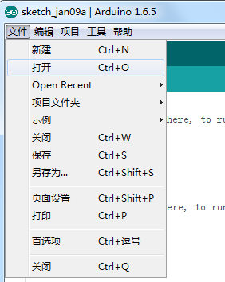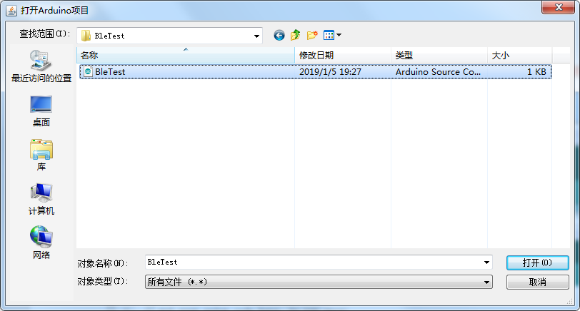

3.2.1 select document figure

1) open the Arduino IDE software and click "tool-port-com19" (port Numbers of different boards are different), as shown in figure 3.2.2

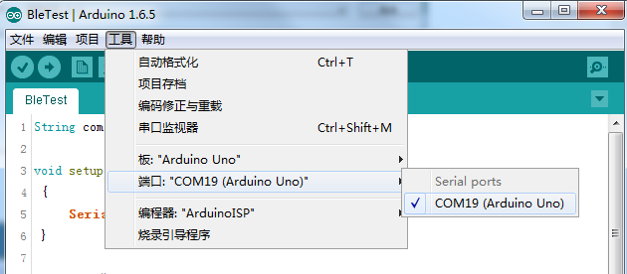

3.2.2 select port figure

1) click "tool-programmer --ArduinoISP"

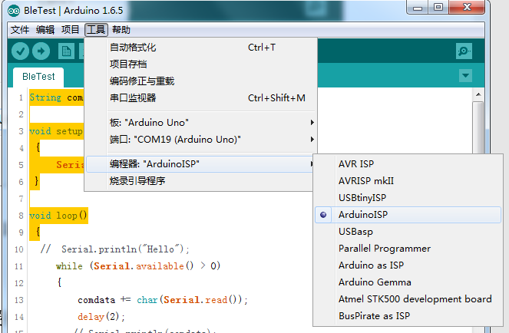

3.2.3 select programmer

1) click the "upload button" to start the upload program

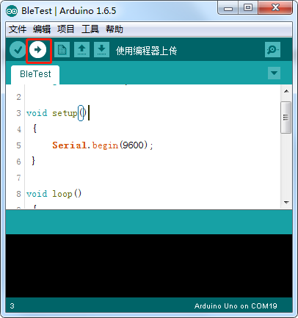

3.2.4 uploading the program

1) start uploading the program, wait for a while, there will be a "upload success" prompt in the bottom left corner, proving that the program has been successfully burned. See figure 3.1.6.

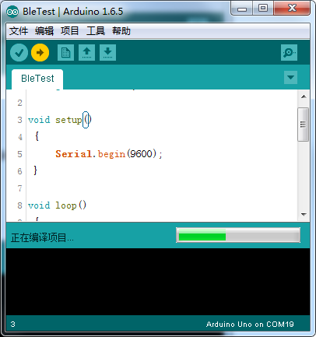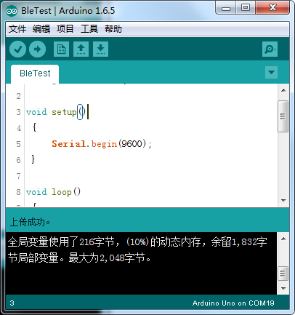

3.2.5 burning 3.2.6 successful burning

1) plug the bluetooth module into the socket of the Arduino UNO expansion board correctly, and then power the Arduino UNO board. At this time, the blue indicator light on the bluetooth module will continuously flash.

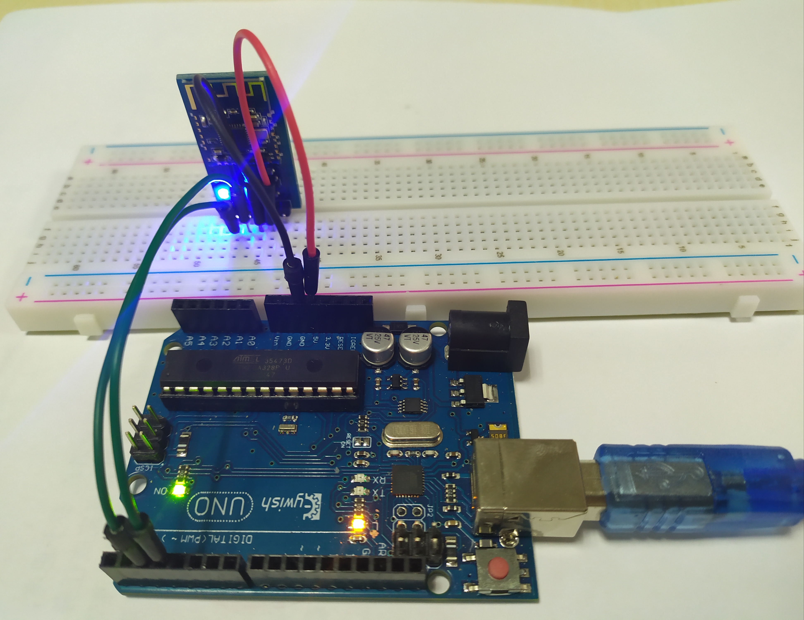

3.2.7blue light flashing

## 3.3 connect the bluetooth

1) install BLETestTools APP on android phone, and the APP installation package is shown in figure 3.3.1;

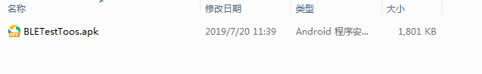

3.3.1 APP installation packag

1) open the serial monitor in the Arduino IDE, as shown in figure 3.3.2

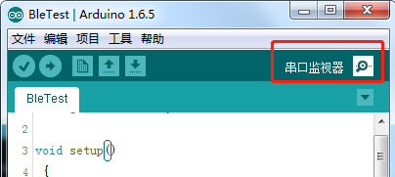

3.3.2 open the serial monitor

1) prepare the serial port monitor, as shown in figure 3.3.3;

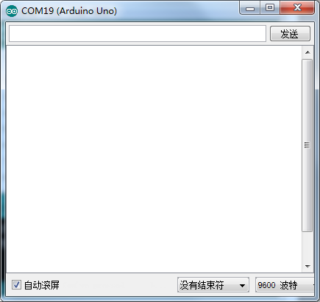

3.3.3 Serial monitor interface

1) open the mobile phone bluetooth, then open the BLETestTools APP, as shown in figure 3.3.4;

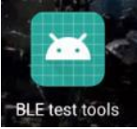 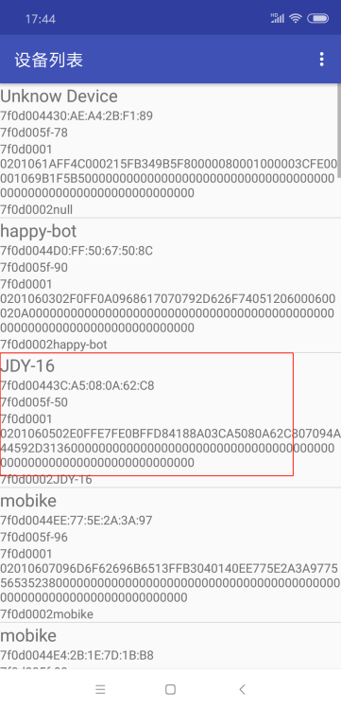 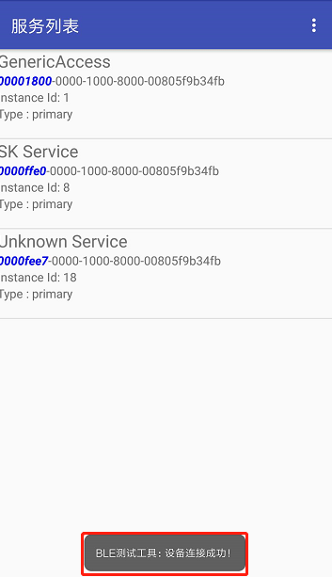

3.3.4 APP 3.3.5 bluetooth list 3.3.6 connected

1) select jdy-16 from the list, as shown in figure 3.3.5; After the connection is successful, the blue LED on the bluetooth module will always be on, and the APP will prompt for successful connection, as shown in figure 3.3.6.

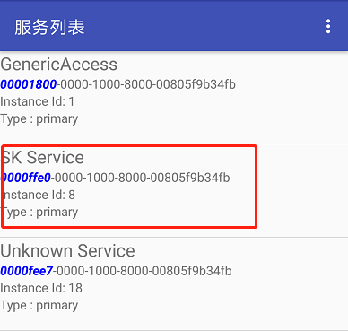 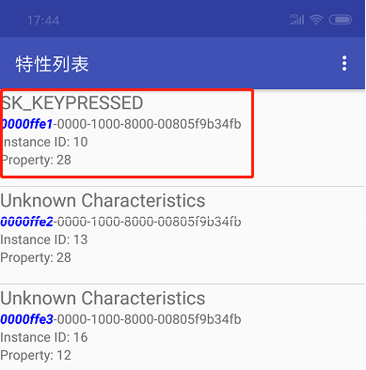

3.2.7 service list 3.2.8 characters list

1) select SK Service from the list of services, as shown in figure 3.3.7, and "SK_KEYPRESSED" from the list of features, as shown in figure 3.3.8

2) select "write", as shown in figure 3.3.9, enter the write character page (as shown in figure 3.3.10), and write a string, such as 1234,

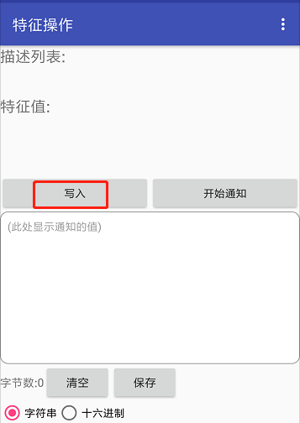 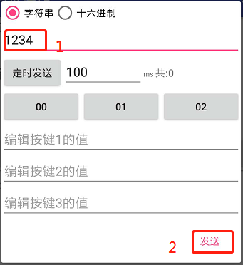

3.3.9 input interface 3.3.10 input characters

1) the serial port monitor will see a string of 1234 displayed, which proves that the bluetooth communication is normal, as shown in figure 3.3.11;

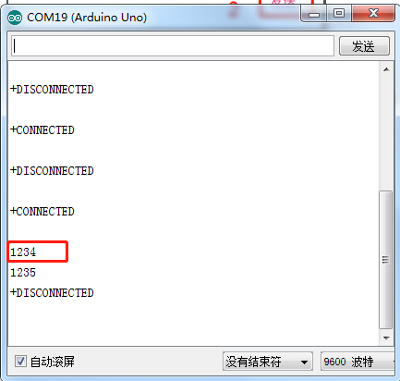 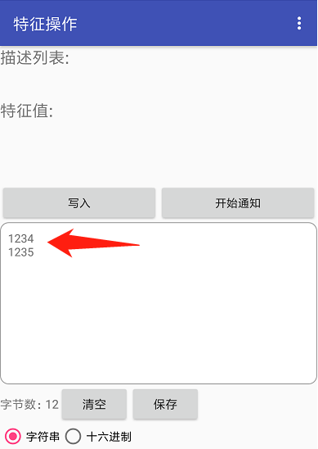

3.3.11 Serial monitor interface 3.3.12 characters sent by serial monitor

1) write a string on the serial port monitor, such as 1235. The APP will receive it.

## 3.4 Mblock test program

Mblock programming

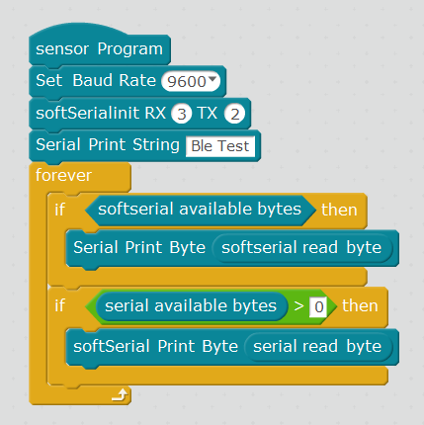

3.4.12mblock program

## 3.5Mixly graphical programming program

Mixly programmed the digital tube program as shown in the figure below:

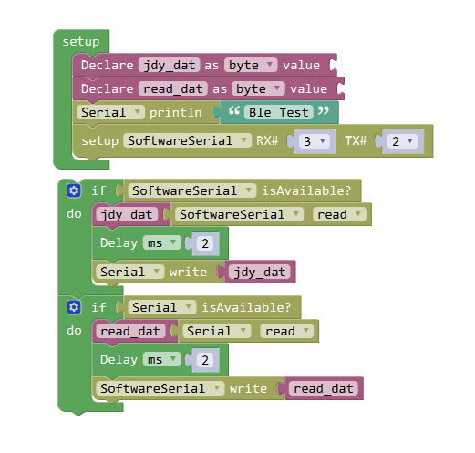

3.5.1Mixly program